**Brief Explanation of Design Decisions:**

### **HTML Structure:**

* **HTML**: Used <header>, <main>, <section>, <footer> for better accessibility.
* **Simple Navigation**: Basic anchor links with IDs for smooth scrolling.
* **Form Elements**: Standard input types with proper labels and validation attributes.

### **CSS Styling:**

* **CSS Reset**: Normalized browser defaults with * { margin: 0; padding: 0; box-sizing: border-box; }.
* **Responsive Design**: Mobile-first approach with media queries for tablets (768px) and phones (480px).
* **Color Scheme**: Professional blue (#007bff) with neutral grays for contrast.
* **Layout**: Flexbox for navigation, centered content with max-width for readability.
* **Visual Feedback**: Hover effects, focus states, and transitions for better UX.

### **JavaScript Functionality:**

* **Event-Driven**: All interactions use addEventListener() for better performance.
* **DOM Manipulation**: Dynamic content updates without page refresh.
* **Form Validation**: Client-side validation with visual feedback.
* **Smooth Scrolling**: Enhanced navigation experience.

**Steps to Run Website:**

**npm install -g http-server**

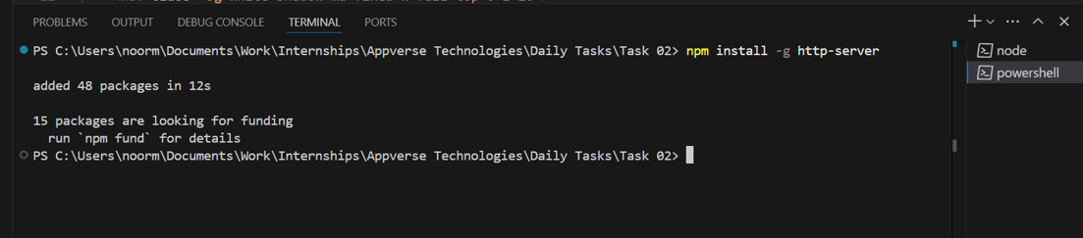

**http-server**

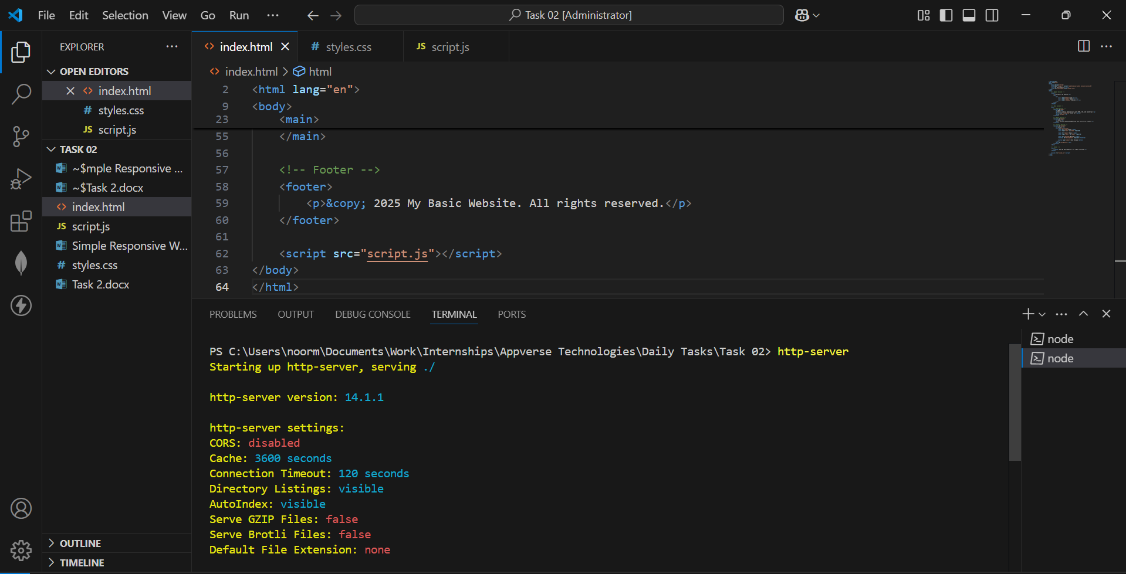

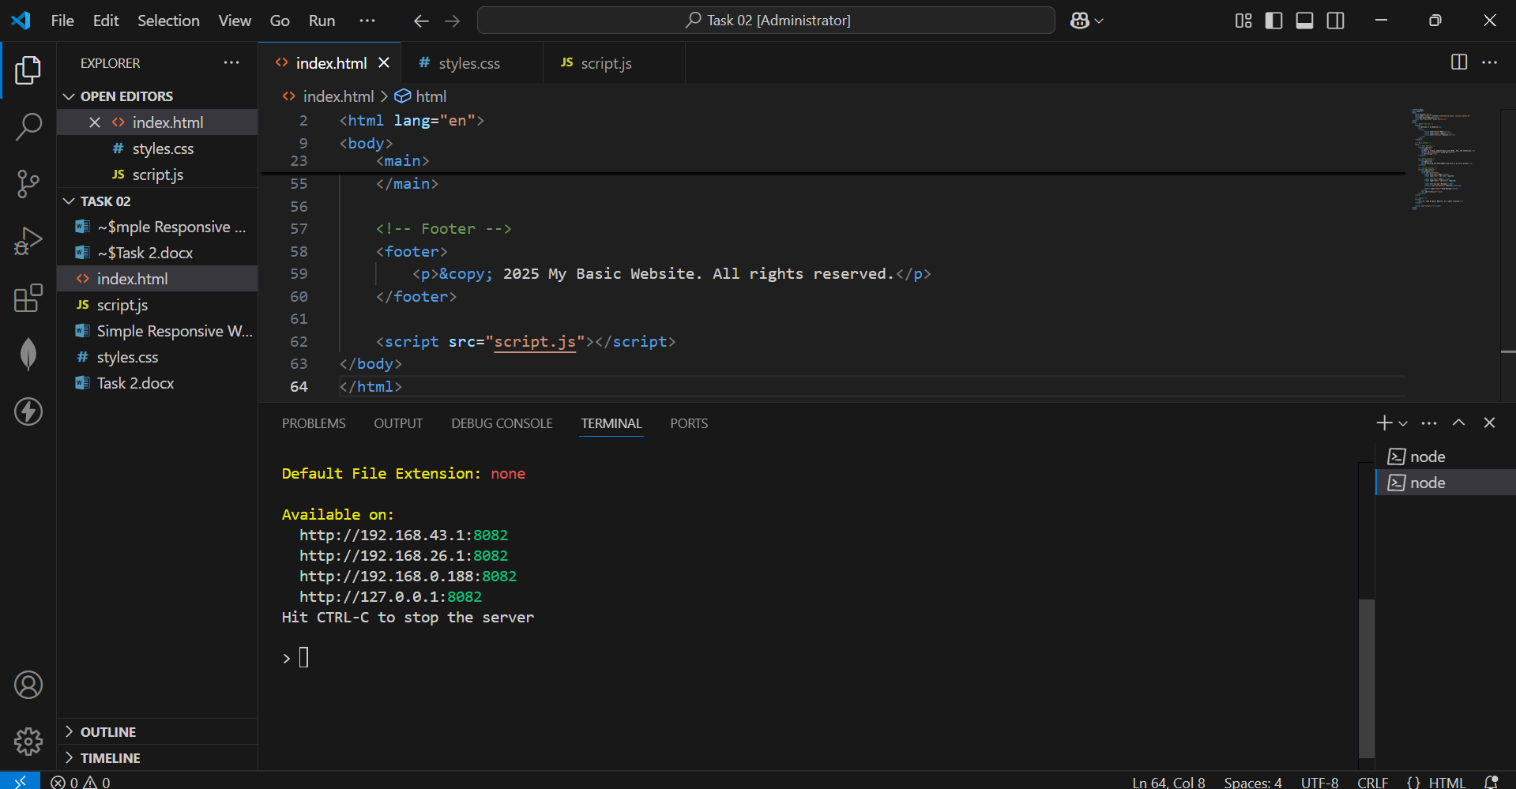

**http://127.0.0.1:8082**

